Ing. Cesar A. Fuoco. Field App Engineer. Electronica Elemon S.A.

Fast Fourier Transform In place function tested within MPLAB X 1.85 – XC16 compiler – Debug Tool Simulator

Code: ( Based on 1676 Class – Microchip Master Conference 2012 )

#include <p33Fxxxx.h>
#include "compositesinewave.h"
#include <dsp.h>

extern IIRTransposedStruct HighpassFilter;
int output[1024];
int i;

#define FFT_BLOCK_LENGTH 512
#define LOG2_BLOCK_LENGTH 9

fractcomplex fftInputOutput[FFT_BLOCK_LENGTH] __attribute__ ((space(ymemory),far));
fractcomplex twiddleFactors[FFT_BLOCK_LENGTH/2] __attribute__ ((space(xmemory)));
fractional preFilterFFTMag[FFT_BLOCK_LENGTH]; // <- Review
fractional postFilterFFTMag[FFT_BLOCK_LENGTH]; // <- Review

int main(void)
{
TwidFactorInit (LOG2_BLOCK_LENGTH, &twiddleFactors[0], 0);

for(i = 0; i < FFT_BLOCK_LENGTH; i ++)
{
fftInputOutput[i].real = ((fractional)compositesinewave[i]) >> 1;
fftInputOutput[i].imag = 0x0;
}

FFTComplexIP(LOG2_BLOCK_LENGTH, fftInputOutput, twiddleFactors, COEFFS_IN_DATA);
BitReverseComplex(LOG2_BLOCK_LENGTH, fftInputOutput);
SquareMagnitudeCplx(FFT_BLOCK_LENGTH, fftInputOutput, preFilterFFTMag);

Nop();
}
Results ( Matlab Plots)

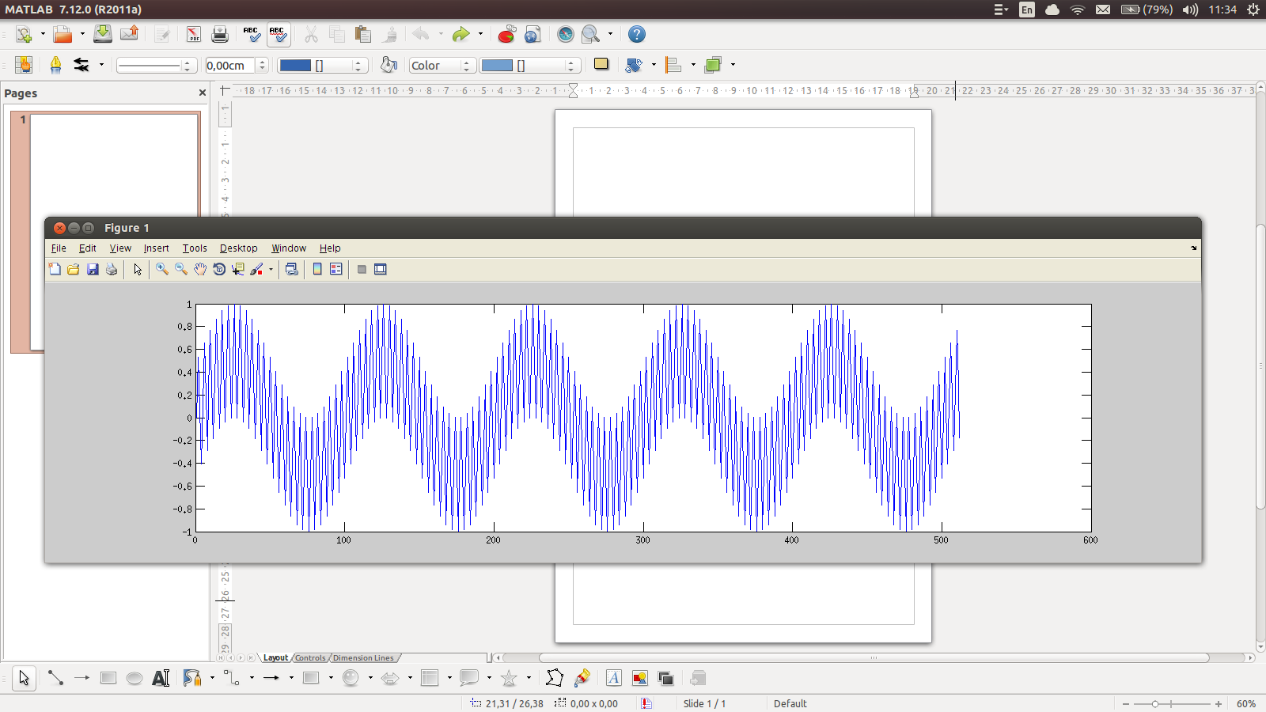

Fig1. Compositesinewave.h

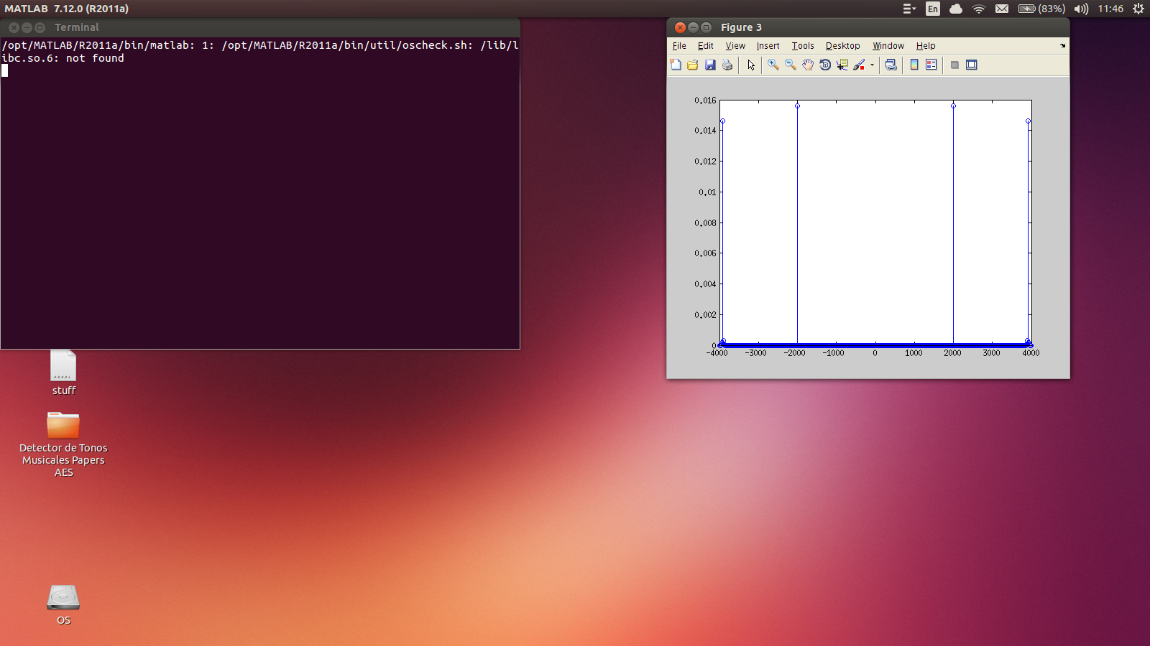
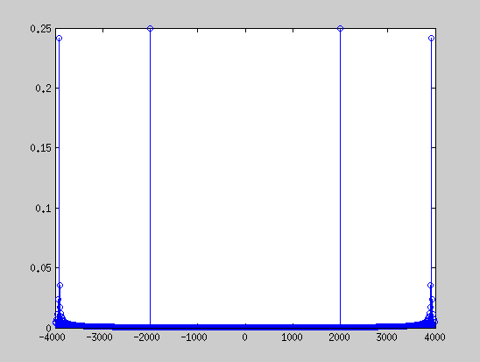

Fig2. Matlab fft fixed point Q15 scaled Fig3. dsPIC33FJ output ( preFilterFFTMag variable )

